**PROFESSIONAL TRAINING REPORT**

**at**

**Sathyabama Institute of Science and Technology**

**(Deemed to be University)**

Submitted in partial fulfilment of the requirement for the award of

Bachelor of Engineering Degree in Computer Science and Engineering

By

**Abhishek Kumar Singh**

**(Reg.No. 40110016)**



**DEPARTMENT OF COMPUTER SCIENCE AND ENGINEERING**

**SCHOOL OF COMPUTING**

**SATHYABAMA INSTITUTE OF SCIENCE AND TECHNOLOGY**

**JEPPIAR NAGAR, RAJIV GANDHI SALAI,**

**CHENNAI – 600119, TAMILNADU**

**OCT 2022**

**SATHYABAMA**

**INSTITUTE OF SCIENCE AND TECHNOLOGY**

**(DEEMED TO BE UNIVERSITY)**

**Accredited with Grade “A” by NAAC**

**(Established under Section 3 of UGC Act, 1956)**

**JEPPIAR NAGAR, RAJIV GANDHI SALAI,**

**CHENNAI – 600119**

[**www.sathyabamauniversity.ac.in**](http://www.sathyabamauniversity.ac.in)

**_______________________________________________________________________________**

**DEPARTMENT OF COMPUTER SCIENCE AND ENGINEERING**

**BONAFIDE CERTIFICATE**

This is to certify that this Project Report is the bonafide work of **Abhishek Kumar Singh (40110016)** who carried out the project entitled “**Online Shopping of Artwork**” under my supervision from Aug 2022 to Oct 2022.

**Internal Guide**

**Mr. Amandeep Singh K, B. E, M. Tech, (PhD)**

**Head of the Department**

__________________________________________________________________________________

**Submitted for Viva voce Examination held on_____________________________**

**InternalExaminer ExternalExaminer**

**DECLARATION**

I **Abhishek Kumar Singh** hereby declare that the Project report entitled “**Online Shopping of Artwork”** done by me under the guidance of **Mr. Amandeep Singh K, B. E, M. Tech, (PhD)** and **Mr. Sankaran Vaidyanathan** at **HCL Technology** is submitted in partial fulfilment of the requirement for the award of Bachelor of Engineering degree in Computer Science and Engineering.



**DATE:**

**PLACE: Chennai SIGNAURE OF THE CANDIDATE:**

**ACKNOWLEDGEMENT**

I am pleased to acknowledge my sincere thanks to Board of Management of SATHYABAMA for their kind encouragement in doing this project and for completing it successfully. I am grateful to them.

I convey my thanks to Dr. T. Sasikala M.E., Ph.D., Dean, School of Computing, Dr.S.Vigneshwari M.E., Ph.D., and Dr.L.Lakshmanan M.E., Ph.D., Heads of the Department of Computer Science and Engineering for providing me necessary support and details at the right time during the progressive reviews.

I would like to express my sincere and deep sense of gratitude to my Project Guide Mr. Amandeep Singh Associate professor CSE dept. for his valuable guidance, suggestions and constant encouragement paved way for the successful completion of my Project work.

I wish to express my thanks to all Teaching and Non-teaching staff members of the Department of Computer Science and Engineering who were helpful in many ways for the completion of the project.

**TRAINING CERTIFICATE**

**ABSTRACT**

This project is a web-based shopping system for an existing shop. The project objective is to deliver the online shopping application into website platform. This project is an attempt to provide the advantages of online shopping to customers of a real shop. It helps buying the products in the shop anywhere through internet by using a browser. The main objective of this application is to make it interactive and its ease of use. It would make searching, viewing and selection of a product easier.

Thus, the customer will get the service of online shopping and home delivery from his favourite shop. This system can be implemented to any shop in the locality or to multinational branded shops having retail outlet chains. If shops are providing an online portal where their customers can enjoy easy shopping from anywhere, the shops won’t be losing any more customers to the trending online shops such as Flipchart or eBay.

They can also view the product reviews and also write their own reviews. The application also provides a drag and drop feature so that a user can add a product to the shopping cart by dragging the item in to the shopping cart. Since the application is available in the Smartphone it is easily accessible and always available.

**i**

**TABLE OF CONTENTS**

**CHAPTER TITLE PAGE**

**No. No.**

ABSTRACT i

LIST OF FIGURES iv

1. **INTRODUCTION** 1

1.1 INTRODUCTION 1

1.2 OBJECTIVE OF PROJECT ON ONLINE 2

ART GALLERY

1.3 PROJECT OVER VIEW 2

2. **AIM AND SCOPE OF THE** 3

**PRESENT INVESTIGATION**

2.1 AIM 3

2.2 SCOPE 3

2.3 PROBLEM STATEMENT 4

2.4 STUDY LIMITATION 4

3. **EXPERIMENTAL OR MATERIALS AND** 5

**METHODS; ALGORITHMS USED**

3.1 STUDY OF THE SYSTEM 5

3.2 SYSTEM TOOLS AND APPLICATIONS 11

3.3 BACKEND TECHNOLOGY 13

**ii**

4. **RESULTS AND DISCUSSION**, 14

**PERFORMANCES ANALYSIS**

4.1 SYSTEM ARCHITECTURE 14

4.2ONLINE SHOPPING ACTIVITY DIAGRAM 18

4.3 ONLINE SHOPPING DOMAIN MODEL 19

4.4 RESULT 20

5. **SUMMARY AND CONCLUSIONS 27**

SUMMARY 27

CONCLUSIONS 28

REFERENCES 29

**iii**

LIST OF FIGURES

FIGURENO. FIGURENAME PAGENO.

3.1.1.1.1 Admin module 5

3.1.1.1.2: Manage Moderator 6

3.1.1.1.2: Manage Products 7

3.1.1.1.2: Manage User 8

3.1.1.1.2: Manage Orders 8

3.1.1.2.1: Moderator Module 9

3.1.1.3.1: User Module 10

4.1.1 SYSTEM ARCHITECTURE 14

4.1.2 Login DFD 15

4.1.3 Admin DFD 16

4.1.4 Registration DFD 17

4.1.5 Moderator DFD 17

4.2.1 Online shopping activity diagram 18

4.3.1 Online shopping domain model 19

**iv**

**CHAPTER-1: INTRODUCTION**

* 1. **INTRODUCTION:**

Computer plays an important role in our daily life. Anything we want we can get only in one mouse click. Speed, reliability and accuracy of the computer make it a powerful tool for different purposes. A very important and basic need of today’s modern business world is the quick availability and processing of information using computer. One can easily get the type of required information within a fraction of a second. The project that I have taken is also in this category which is used in our daily life whenever we want to purchase some items, we can easily get them at our home.

The” Online Shopping of Artwork” has been developed to override the problems prevailing in the practicing manual system. This Software is supported to eliminate and, in some cases, reduce the hardships faced by this existing system. Moreover, this system is designed for the particular need of the company to carry out operations in a smooth and effective manner.

The application is reduced as much as possible to avoid errors while entering the data. It also provides error message while entering invalid data. No formal knowledge is needed for the user to use this system. Thus, by this all it proves it is user-friendly.” Online Shopping of Artwork”, as described above, can lead to error free, secure, reliable and fast management system. It can assist the user to concentrate on their other activities rather to concentrate on the record keeping. Thus, it will help organization in better utilization of resources.

Every organization, whether big or small, has challenges to overcome and managing the information of Order, Arts, Customer, Art Gallery, Stock. Every” Online Shopping of Artwork” has different Art’s needs; therefore, we design exclusive employee management systems that are adapted to your managerial requirements. This is designed to assist in strategic planning, and will help you ensure that your organization is equipped with the right level of information and details for your future goals. Also, for those busy executive who are always on the go, our systems come

**1**

who are always on the go, our systems come with remote access features, which will allow you to manage your workforce anytime, at all times. These systems will ultimately allow you to better manage resources.

**1.2 OBJECTIVE OF PROJECT ON ONLINE ART GALLERY:**

The main objective of the Project on Online Art Gallery is to manage the details of Arts, Order, Order Update, Customer, Stock. It manages all the information about Arts, Art Gallery, Stock, Arts. The project is totally built at administrative end and thus only the administrator is guaranteed the access. The purpose of the project is to build an application program to reduce the manual work for managing the Arts, Order, Art Gallery, Order Update. It tracks all the details about the Order Update, Customer, Stock.

**Functionalities provided by Online Art Gallery are as follows:**

🡪Provides the searching facilities based on various factors. Such as Arts, Order

Update, Customer, Stock.

🡪 Online Art Gallery also manage the Art Gallery details online for Customer details,1Stock details, Arts.

🡪 It tracks all the information of Order, Art Gallery, Customer etc.

🡪 Manage the information of Order.

🡪Shows the information and description of the Arts, Order Update.

🡪To increase efficiency of managing the Art, Order.

* 1. **PROJECT OVER VIEW:**

The central concept of the application is to allow the customer to shop virtually using the Internet and allow customers to buy the items and articles of their desire from the store. The information pertaining to the products are stores on an RDBMS at the server side (store). The Server process the customers and the items are shipped to the address submitted by them. The application was designed into two modules first is for the customers who wish to buy the articles. Second is for the storekeepers who

**2**

maintains and updates the information pertaining to the articles and those of the customers. The end user of this product is a departmental store where the application is hosted on the web and the administrator maintains the database. The application which is deployed at the customer database, the details of the items are brought forward from the database for the customer view based on the selection through the menu and the database of all the products are updated at the end of each transaction. Data entry into the application can be done through various screens designed for various levels of users. Once the authorized personnel feed the relevant data into the system, several reports could be generated as per the security.

**CHAPTER-2: AIM AND SCOPE OF THE PRESENT**

**INVESTIGATION**

**2.1 AIM:**

The central concept of the application is to allow the customer to shop virtually using the Internet and allow customers to buy the items and articles of their desire from the store. The primary goal of e-commerce Artwork is **to reach maximum customers at the right time to increase sales and profitability of the business**. Functions of e-commerce include buying and selling goods, transmitting funds or data over the internet.

**2.2 SCOPE:**

It may help collecting perfect management in details. In a very short time, the collection will be obvious, simple and sensible. It will help a person to know the management of passed year perfectly and vividly. It also helps in current all works relative to Online Art Gallery. It will be also reduced the cost of collecting the management & collection procedure will go on smoothly.

**🡨Our project aims at Business process automation, i.e., we have tried to computerize various processes of Online Art Gallery.**

🡪In computer system the person has to fill the various forms & number of copies of the forms can be easily generated at a time.

**3**

🡪In computer system, it is not necessary to create the manifest but we can directly print it, which saves our time.

🡪To assist the staff in capturing the effort spent on their respective working areas.

🡪To utilize resources in an efficient manner by increasing their productivity through automation.

🡪The system generates types of information that can be used for various purposes.

* Reports Of Online Shopping Artwork:

1. It generates the report on Arts, Order, Art Gallery.
2. Provide filter reports on Order Update, Customer, Stock.
3. You can easily export PDF for the Arts, Art Gallery, Customers.
4. It provide excel Export for Order, Order Update, Stock.

**2.3 PROBLEM STATEMENT:**

Build a website for an Art Gallery that specialises in Indigenous Art and the Indigenous community. The HCL Technology Art Gallery is looking for as ite to showcase the art of their members. The site is to have a gallery of the art prices with descriptions, profiles of the members and information about the gallery and about exhibitions that the gallery can changes as they happen.

Also attaining artwork to use on the site that looks authentic but does not infringe on copyright of indigenous people could be an issue.

**2.4 STUDY LIMITATION:**

The lack of time was the main the limitation. Secondly, because there is such system in our country but they are that very well known to everyone so there may be some difficulties to implement and convince people to use this system. As Customer uses the same E-commerce’s website even for Artworks and they have to stratified with the limited Stock/Products.Inspite Indian been country for Culture and Tradition and also having the supplies (Products and different stocks from different culture) which is of affordable price. Still Customer have to go with old and confide Products.

**4**

**CHAPTER-3: EXPERIMENTAL OR MATERIALS AND METHODS; ALGORITHMS USED**

**3.1 STUDY OF THE SYSTEM:**

**3.1.1 MODULES:**

The system after careful analysis has been identified to be presented with the following modules and roles. The modules involved are: ¬

1. Administrator
2. Moderators
3. Users

**3.1.1.1 ADMINISTRATOR:**

The administrator is the super user of this application. Only admin have access into this admin page. Admin may be the owner of the shop. The administrator has all the information about all the users and about all products.

🡪This module is divided into different sub-modules.

1. Manage Moderators

2. Manage Products

3. Manage Users

4. Manage Orders

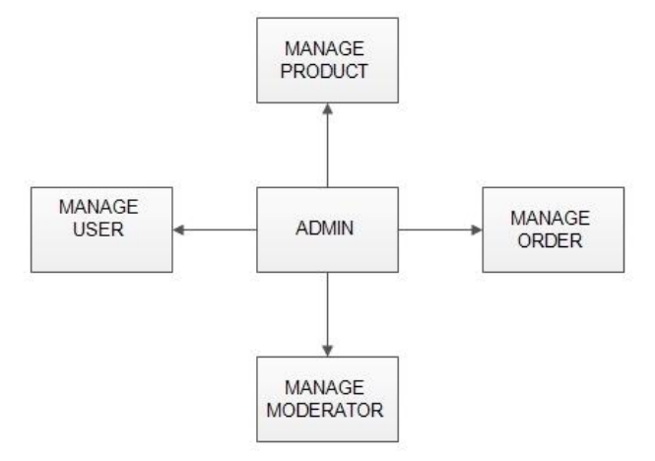

Fig 3.1.1.1.1: Admin module

**5**

**MANAGE MODERATOR**

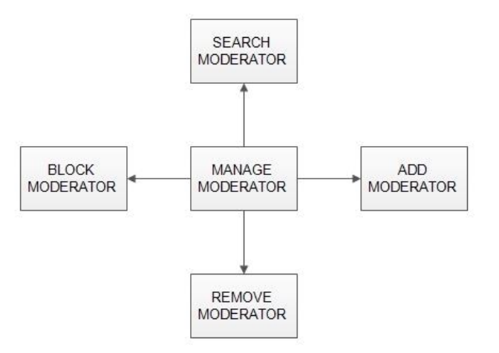

Fig 3.1.1.1.2: Manage Moderator

* **Add Moderator: -**

Only admin is having the privilege to add a moderator. A moderator can be considered as a staff who manages the orders or owner of a group of products.

* **Block Moderator: -**

Admin can restrict a moderator from managing the orders by blocking them. Admin can unblock a blocked user if needed.

* + - **Remove Moderator**:

Admin has privilege to delete a moderator who was added

* + - **Search moderator**:

All existing moderators can be viewed by the administrator as a list. If there is number of moderators and admin need to find one of them, the admin can search for a moderator by name

**6**

**MANAGE PRODUCTS**

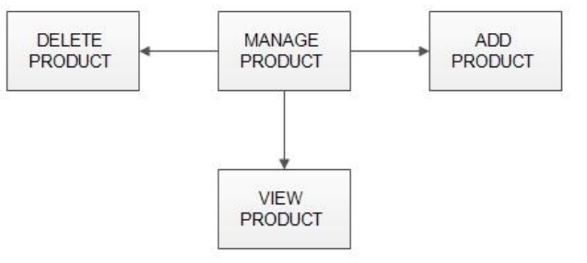

Fig 3.1.1.1.3: Manage Products

* **Add Products:**
* The shopping cart project contains different kind of products. The products can be classified into different categories by name. Admin can add new products into the existing system with all its details including an image.
* **Delete Products:**

Administrator can delete the products based on the stock of that particular product.

* **Search products:**

Admin will have a list view of all the existing products. He can also search for a particular product by name.

**MANAGE USER**

* **View Users:**

The admin will have a list view of all the users registered in the system. Admin can view all the details of each user in the list except password.

* **Add Users**:

Admin has privileges to add a user directly by providing the details.

**7**

* **Delete &Block Users:**

Administrator has a right to delete or block a user. The default status of a new user registered is set as blocked. The admin must accept the new user by unblocking him.

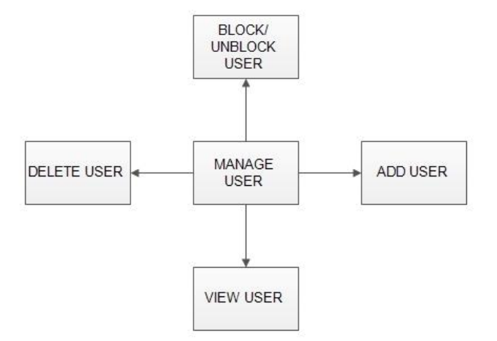

Fig 3.1.1.1.4: Manage User

**MANAGE ORDERS:**

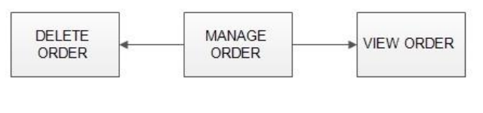

Fig 3.1.1.1.5: Manage Orders

* + **View Order:**

Administrator can view the Orders which is generated by the users. He can verify the details of the purchase.

**8**

* + **Delete order:**

Admin can delete order from the orders list when the product is taken for delivery.

**3.1.1.2 MODERATORS:**

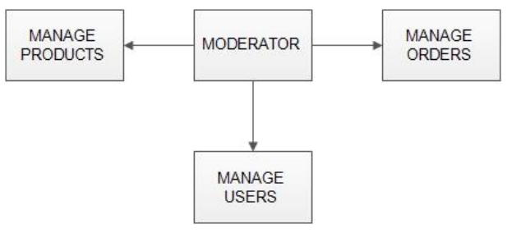

Fig 3.1.1.2.1: Moderator Module

A moderator is considered as a staff who can manage orders for the time being. As a future update moderator may give facility to add and manage his own products. Moderators can reduce the work load of admin. Now moderator has all the privilege an admin having except managing other moderators. He can add products and users. He can also check the orders and edit his profile.

* Manage products
* Manages users
* Manage orders

**3.1.1.3 USERS:**

* **Registration:** A new user will have to register in the system by providing essential details in order to view the products in the system. The admin must accept a new user by unblocking him.
* **Login:** A user must login with his user’s name and password to the system after registration.

**9**

* **View Products:** User can view the list of products basedon their names after successful login. A detailed description of a particular product with product name, products details, product image, price can be viewed by users.
* **Search Product:** Users can search for a particular product in the list by name
* **Add to cart:** The user can add the desired product into his cart by clicking add to cart option on the product. He can view his cart by clicking on the cart button. All products added by cart can be viewed in the cart. User can remove an item from the cart by clicking remove.
* **Submit Cart:** After confirming the items in the cart the user can submit the cart by providing a delivery address. On successful submitting the cart will become empty.
* **History:** In the history the user will have a view of pending orders.
* **Edit Profile:** The user can view and edit the profile.

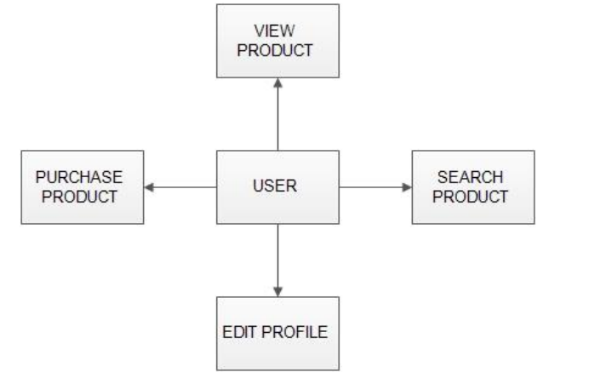

Fig 3.1.1.3.1: User Module

**10**

**3.2 SYSTEM TOOLS & APPLICATIONS:**

The purpose of this project is to build an Online Appointment and Database Management System. It is important for the user to understand how this application works and knowing the technologies that are used to implement this project. For a better understanding, all steps are described in detail to give a full overview of the system.

**3.2.1 Web Server:**

Role of a web server is to communicate between the client side and server side by storing, processing and delivering web pages to the client side. Usually, web browser initiates the communication using HTTP by sending the request of a specific resource and server gives the response with the content of that requested resource. For this project work, Apache HTTP server was chosen, and it exists on the WAMP service. Apache HTTP server is one of the popularly used web server software used in a lot of project works.

**3.2.2 Programming Languages:**

In this project, PHP was programming language and MySQL was selected as a backend database. HTML, CSS, and JavaScript were used for the client-side work.

**3.2.3 PHP:**

PHP is a server-side programming language commonly used to develop dynamic web pages. It is free and accessible in numerous different versions. It can be used on multiple OS such as macOS, windows, UNIX and different platforms. Because it is a scripting language so in this program is taken after the program execution. PHP can also be used in desktop applications. One of the reasons for choosing PHP in this project is that it supports MySQL which is chosen as database in our project.

**11**

PHP programming language makes to present images and PDF files on HTML pages.

**3.2.4 Client-side programming:**

For the development and designing of web pages HTML, CSS and JavaScript languages were used. HTML for creating the web pages, CSS for styling and for adding further functionalities JavaScript was used.

**3.2.4 JavaScript:**

JavaScript is dynamic, high-level scripting language and considered to be one of the core three technologies of the world wide web. It is considered an important part of a web application. It is used for adding functionalities and making web pages interactive. In simple words, it informs the browser about a certain activity or event that occurred and changes the web page as a response to that event, for example, a click on a button.

**3.2.5 HTML:**

Hypertext markup language (HTML) is used for creating web pages and web applications. It describes the structure of the web pages. Information from the HTML documents is sent to the web browser to render or display on the multimedia pages. Html used to describe the structure of a document by presenting a document in a heading, paragraph, image, list, links and other objects like that. Web browser presents the HTML document by using its tags.

**3.2.6 CSS:**

It is important to make HTML pages attractive to the users and for this purpose, developers choose colors, nice fonts, and different layouts. All this work is done by

**12**

the CSS. In short, CSS is used for styling of a HTML document. It is designed in such a way that enables separation of content and presentation so that it makes easier any change of content without interfering with a design. It also enables multi web pages to share the single CSS file for styling to reduce repetition and complexity.

**3.3 BACKEND TECHNOLOGY:**

For this project work, MySQL and PHP was chosen as a database.

**3.3.1 MySQL:**

It is an open-source relational database management system which aims to offer multiple user access to several databases. In simple words, a database is a collection of data which can be a list of shopping items, number of items in a shopping centre or even a vast amount of numerous data in a corporate network. To manage such kind of data, a database management system is required such as MySQL which aims to access data and perform functions like add, remove or edit data. Since MySQL is a relational database so it stores data in different tables instead of putting into a large storeroom. Storing /organizing data into tables increases the accessibility speed and flexibility. Applications which demand availability and scalability use MySQL. Because it has the capability to recover and cope with failures on the host, MySQL, operating system or the hardware that may cause downtime.

**3.3.2 Software Tools:**

For this project work following source tools were chosen to perform various tasks:

* VScode
* PHP server
* Local host server
* MySQL lb

**13**

**CHAPTER-4: RESULTS AND DISCUSSION, PERFORMANCE ANALYSIS**

**4.1 SYSTEM ARCHITECTURE:**

The system architecture of this system is divided/split into two parts. One is the client side and the other is the server side. Client-side is the user interface whereas the server side is the combination of web pages written by PHP and the MySQL database. PHP pages contain the written SQL queries which make the accessibility to database possible. The following figure shows the architecture of the system while the detail of the technologies used in this application is discussed in chapter.

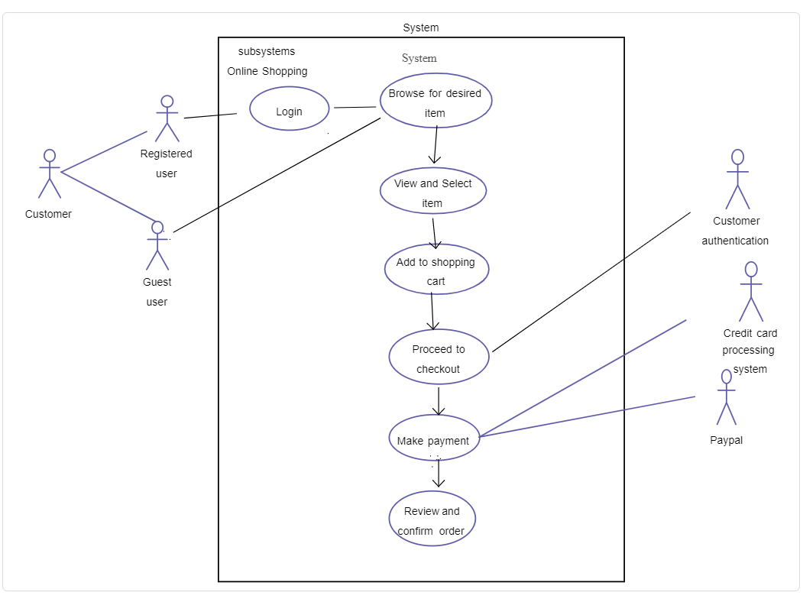

Fig 4.1.1 SYSTEM ARCHITECTURE

**14**

* **PROCESS:**

A process shows a transformation or manipulation of data flow within the system. The symbol used is an oval shape.

* **DATAFLOW**:

The data flow shows the flow of information from a source to its destination. Data flow is represented by a line, with arrowheads showing the direction of flow. Information always flows to or from a process and may be written, verbal or electronic. Each data flow may be referenced by the processes or data stores at its head and tail, or by a description of its contents.

* **DATA STORE:**

A data store is a holding place for information within the system: It is represented by an open-ended narrow rectangle. Data stores may be long-term files such as sales ledgers, or may be short-term accumulations: for example, batches of documents that are waiting to be processed. Each data store should be given a reference followed by an arbitrary number.

**LOGIN DFD:**

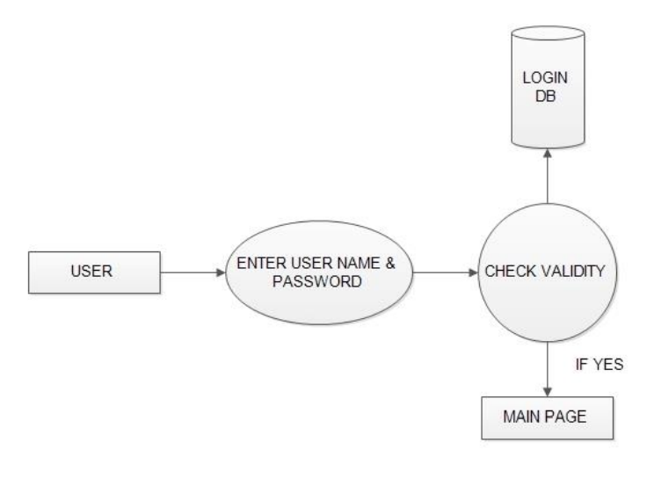

Fig 4.1.2 Login DFD

**15**

**ADMIN DF**

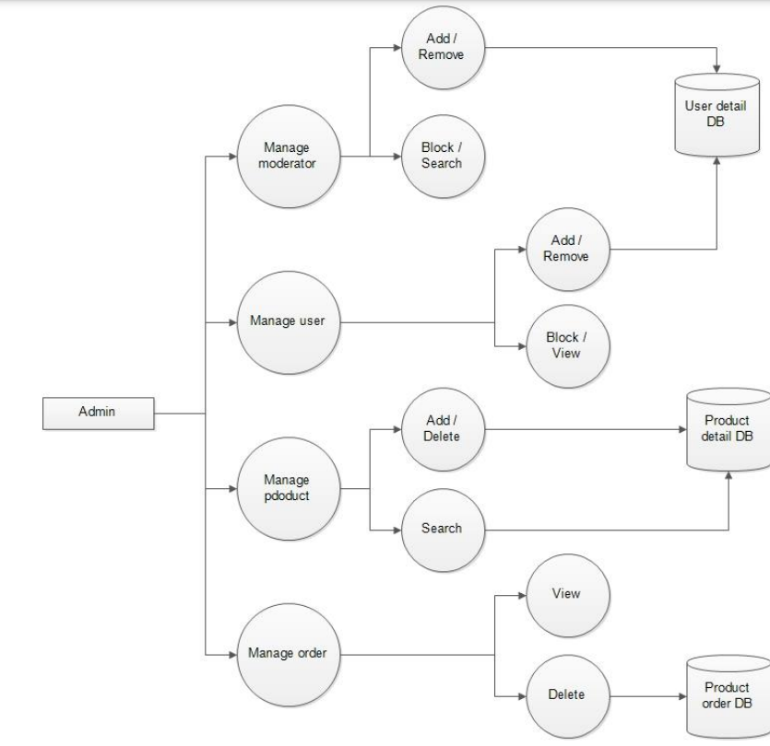

Fig 4.1.3: Admin DFD

**16**

**REGISTRATION DFD:**

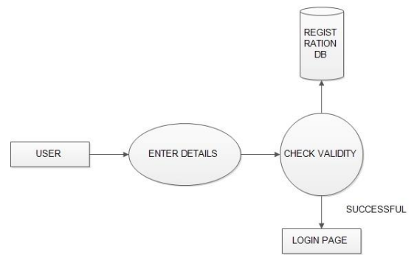

Fig 4.1.4: Registration DFD

**MODERATOR DFD**

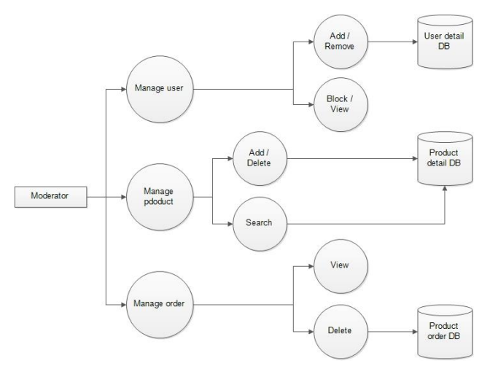

Fig 4.1.5: Moderator DFD

**17**

**4.2 ONLINE SHOPPING ACTIVITY DIAGRAM:**

An example of activity diagram for online shopping. Online customer can browse or search items, view specific item, add it to shopping cart, view and update shopping cart, checkout. User can view shopping cart at any time. Checkout is assumed to include user registration and login.

This example does not use partitions, most of the actions are assumed to be fulfilled by online customer.

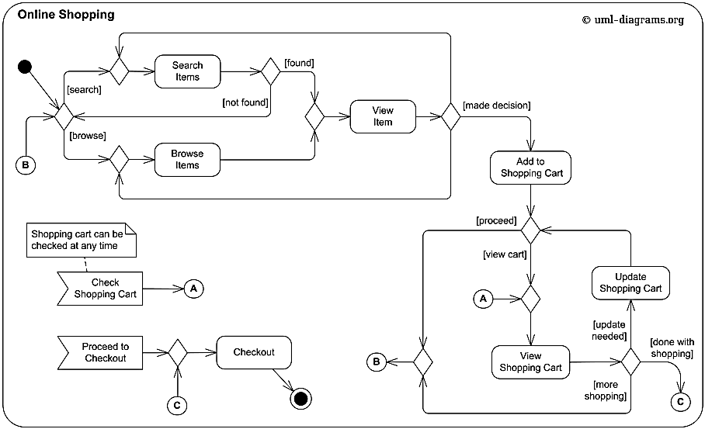

Fig 4.2.1 Online shopping activity diagram

**18**

**4.3 ONLINE SHOPPING DOMAIN MODEL:**

Here we provide an example of UML [**class diagram**](https://www.uml-diagrams.org/class-diagrams-overview.html) which shows a domain model for online shopping. The purpose of the diagram is to introduce some common terms, "dictionary" for online shopping - Customer, Web User, Account, Shopping Cart, Product, Order, Payment, etc. and relationships between. It could be used as a common ground between business analysts and software developers.

Each customer has unique id and is linked to exactly one **account**. Account owns shopping cart and orders. Customer could register as a web user to be able to buy items online

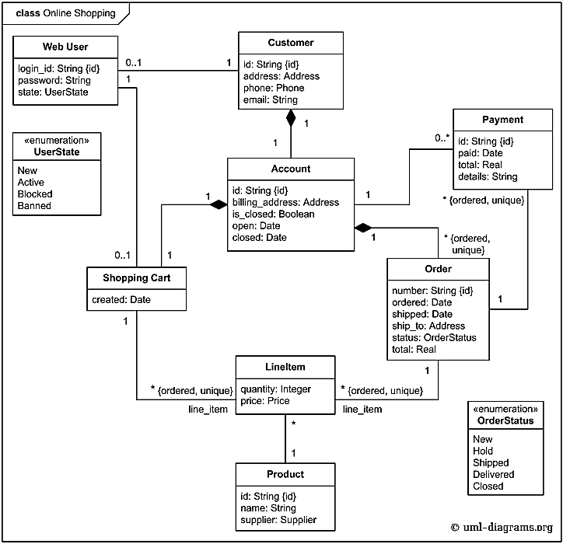

Fig 4.3.1 Online shopping domain model

**19**

**4.4 RESULT:**

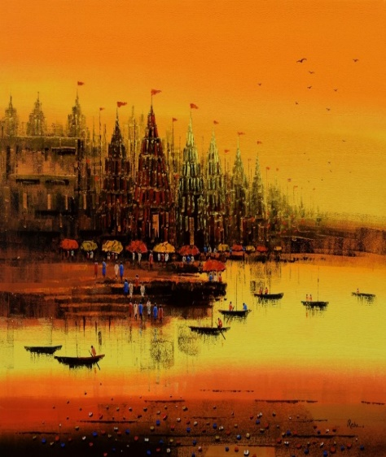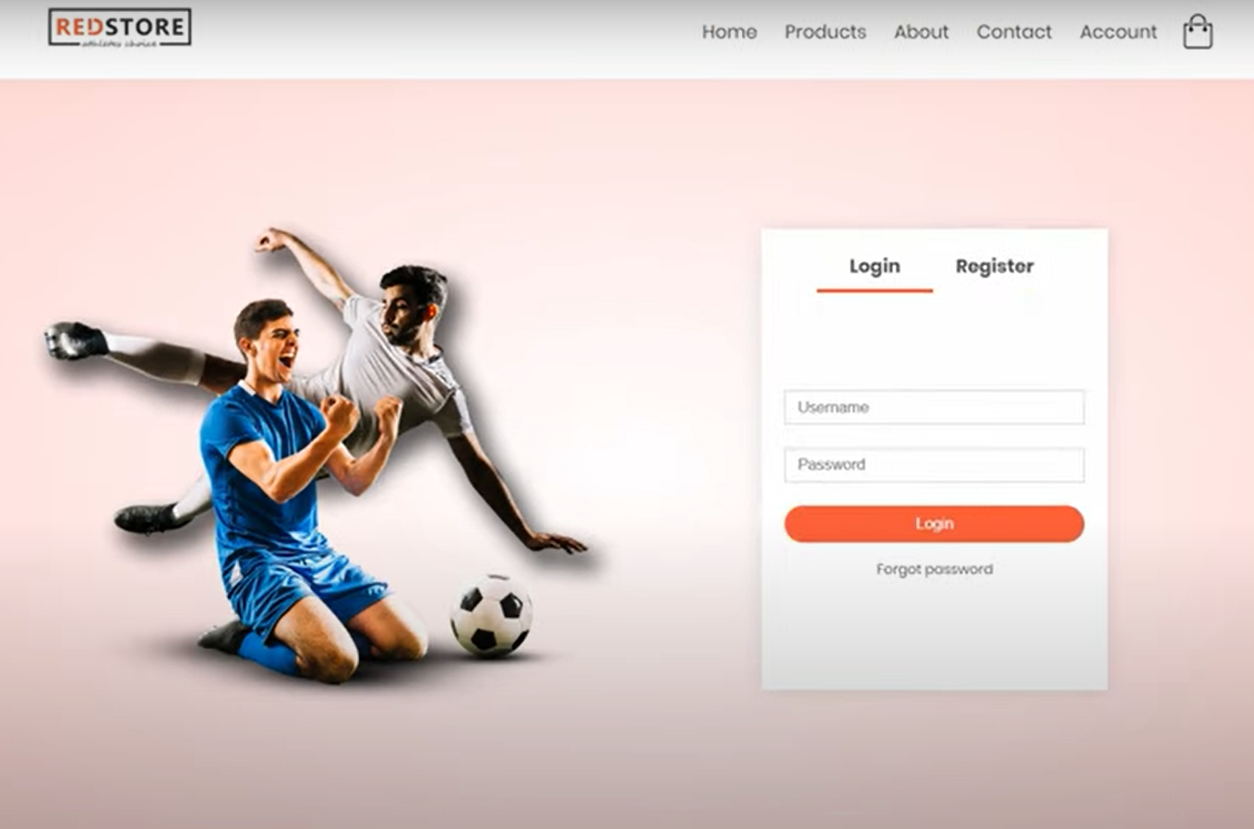

**Fig 4.4.1 login page**

 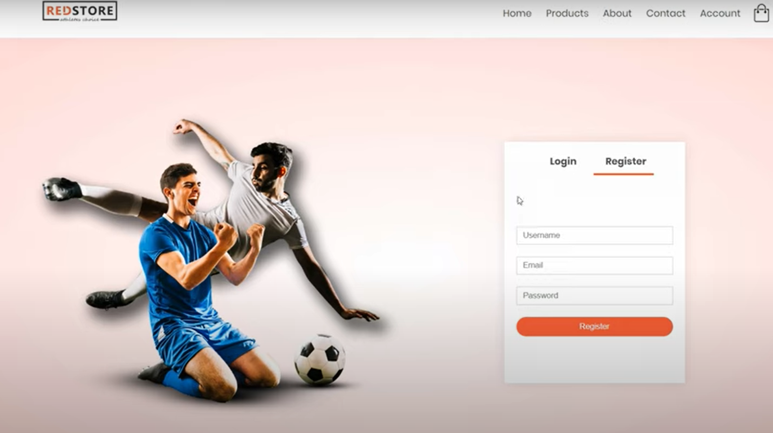

**Fig 4.4.2 Registration Page**

**20**

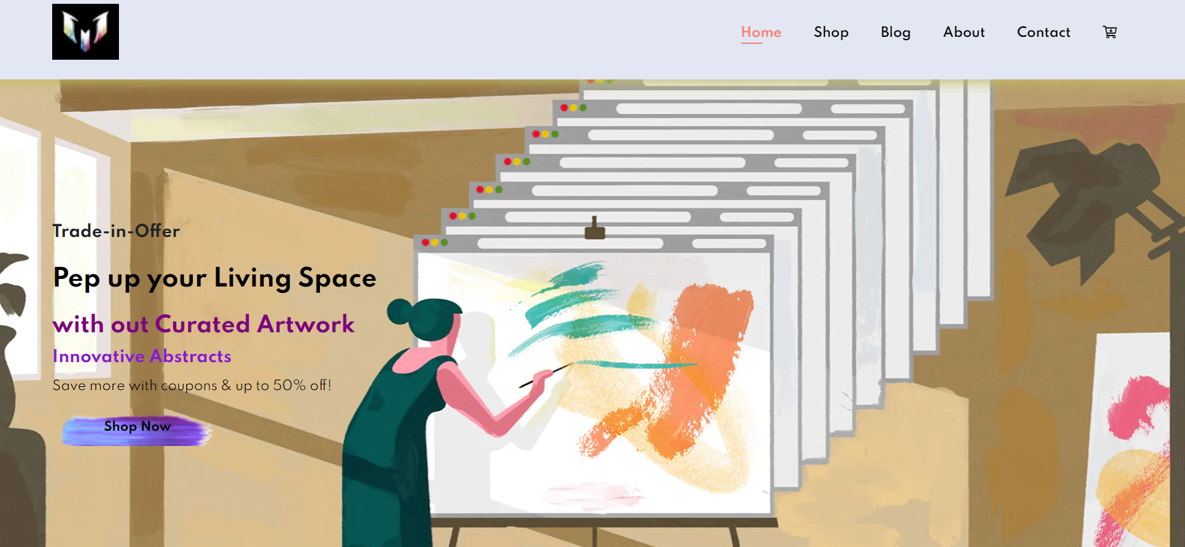

**Fig 4.4.3 Home page**

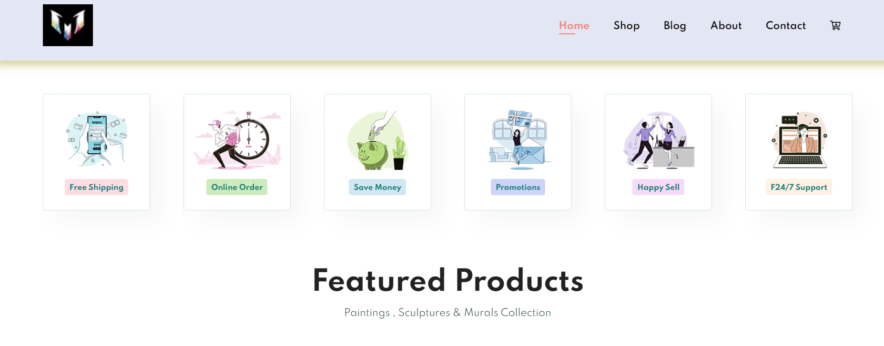

**Fig 4.4.4 Support Page**

**21**

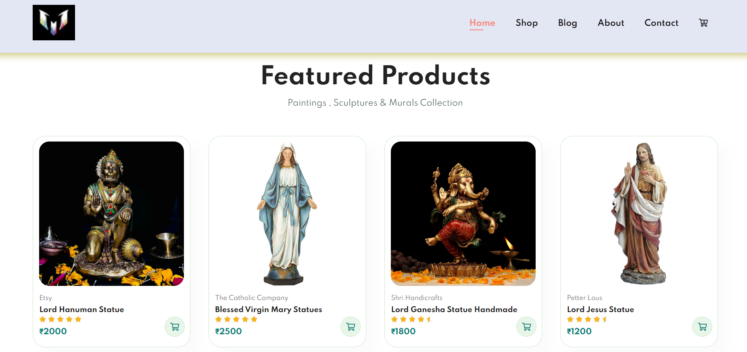

**Fig 4.4.5 Home- Front-display Page**

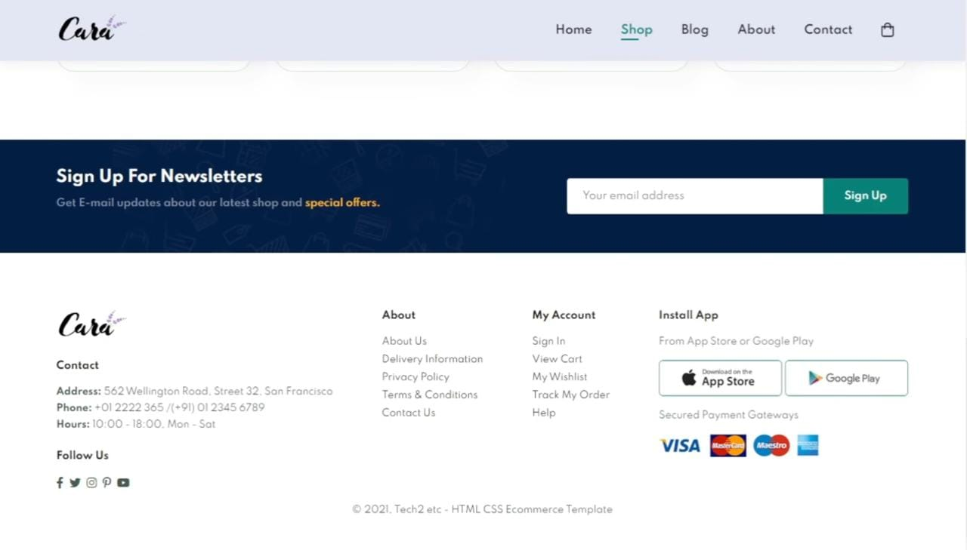

**Fig 4.4.6 Bottom Page Description**

**22**

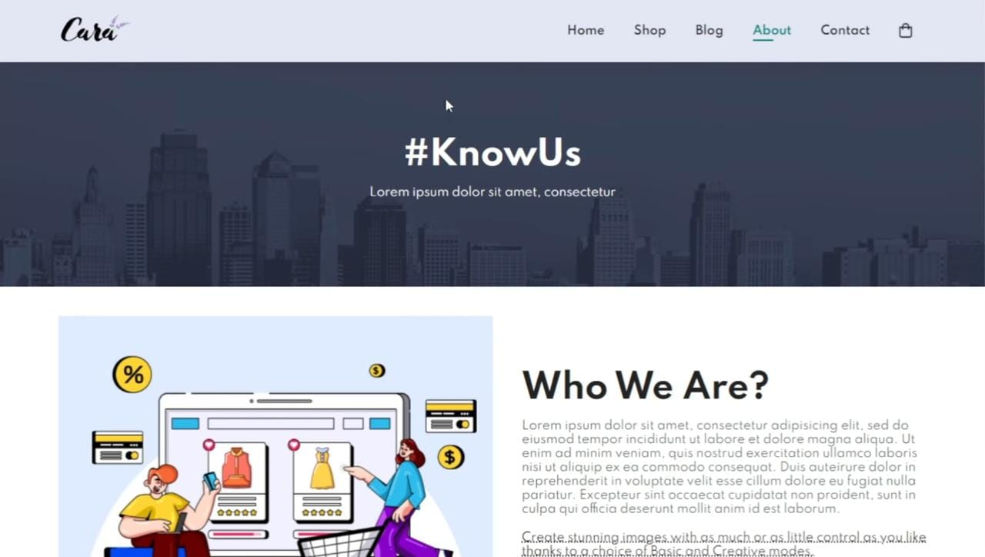

**Fig 4.4.7 About Session**

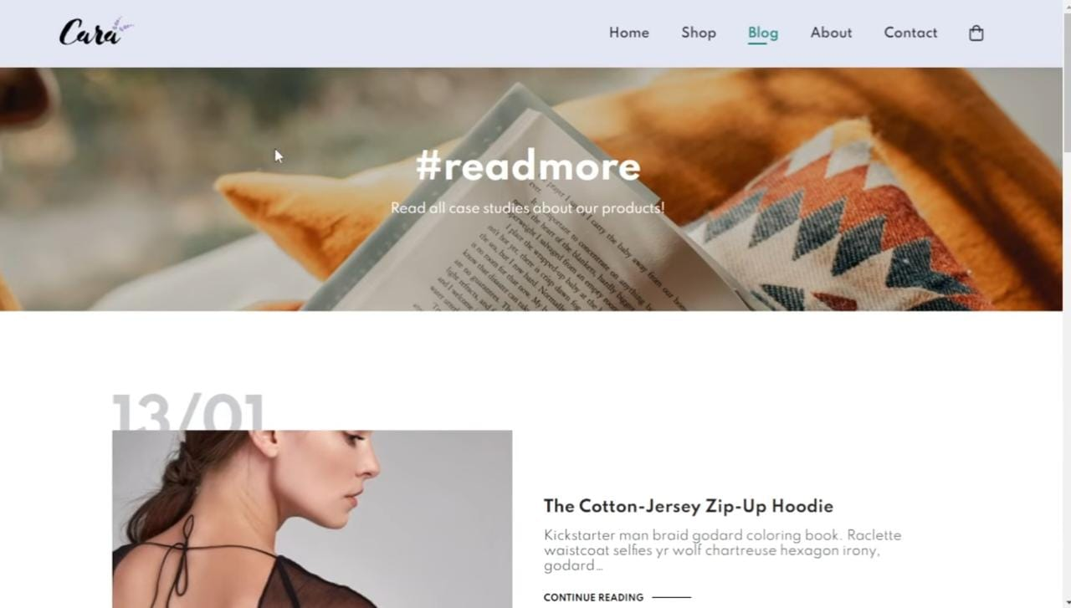

**Fig 4.4.8 Blog Session**

**23**

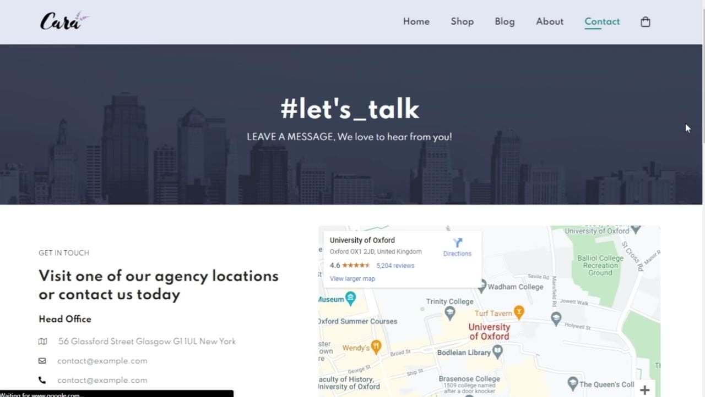

**Fig 4.4.9 Contact Page**

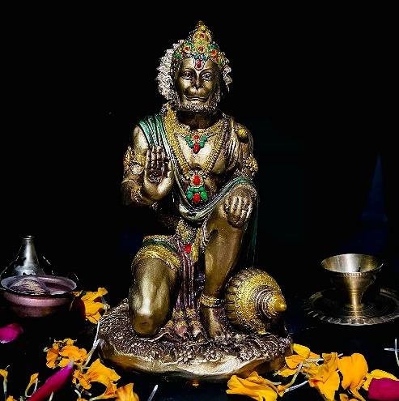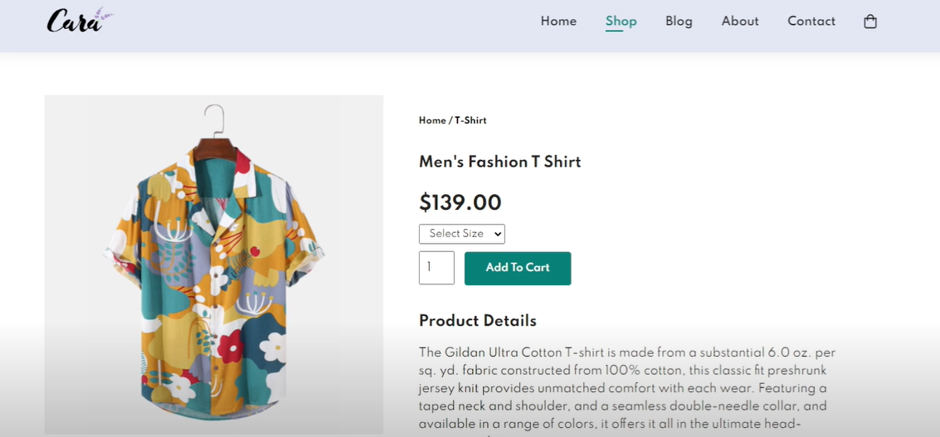

**Fig 4.4.10 Product view page**

**24**



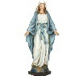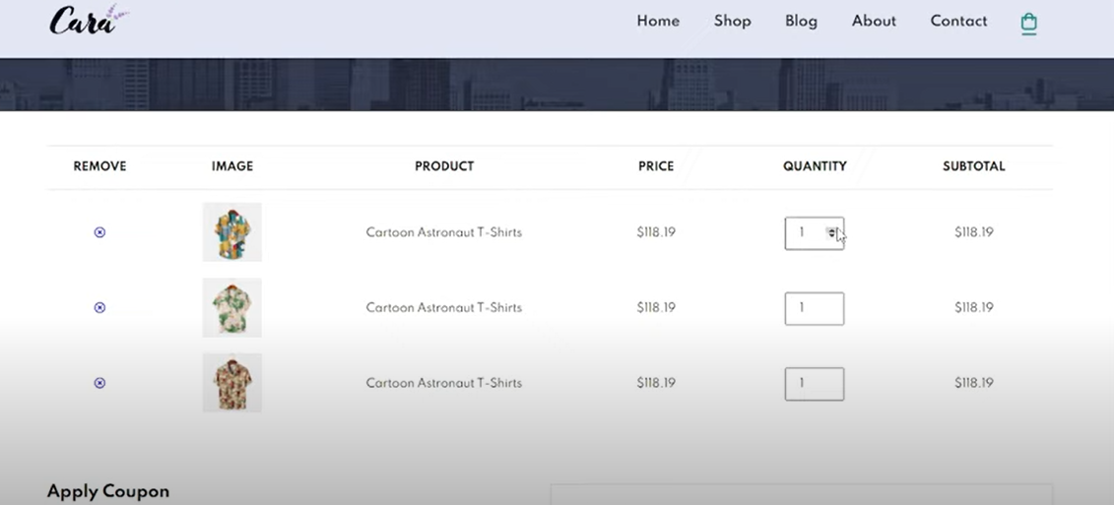

**Fig 4.4.11 Cart Page**

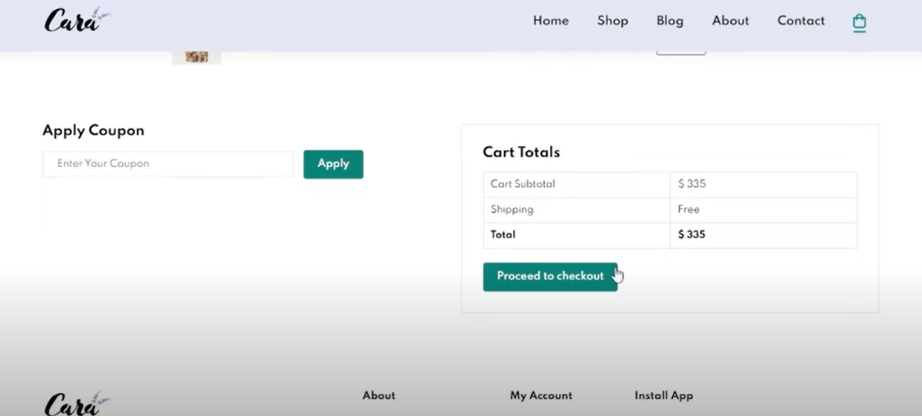

**Fig 4.4.12 Cart Page**

**25**

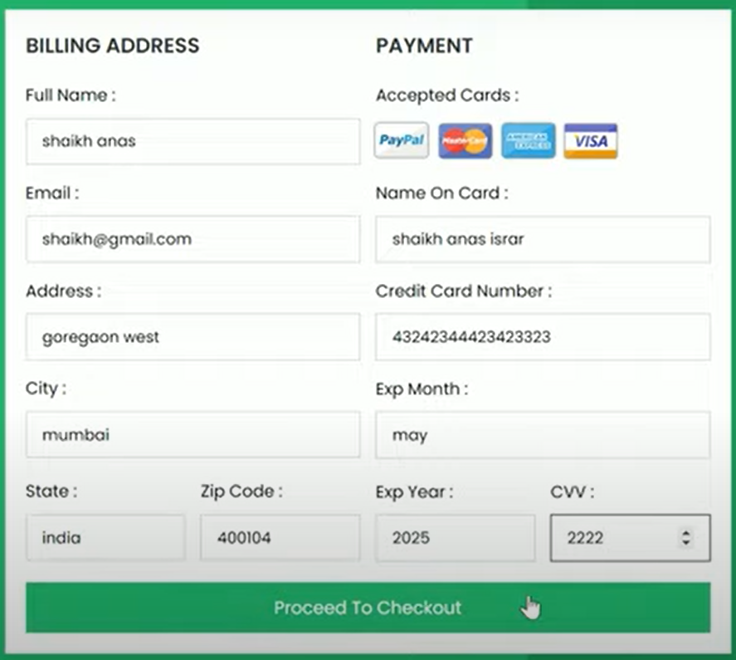

**Fig 4.4.13 Payment portal**

**26**

## **CHAPTER-5: SUMMARY AND CONCLUSIONS**

**5.1 SUMMARY:**

An online shopping of Artwork system is a process in which people (specifical customers) are being provided with the option of purchasing goods and services directly from the seller, all in a real-time environment. Online shopping of Artwork is an application of the internet as electronic commerce. From the business perspective, customers usually find the products more attractive, on websites, as they get all the details available there. People in large number are doing online shopping today, and it is not only because it is convenient as one can shop from home, but also because there is an ample number of varieties available, with a high competition of prices, and also it is easy to navigate for searching regarding any particular item.

For sellers, their product has access to the World-Wide market, which also increases the number of customers and enhances customer relationships. Also, web stores are a means for small-scale companies to launch their products at the global level. The main objective of this project is to develop a web-oriented application that can provide an online shopping feature to users.



Fig 5.1.1 E-Commerce’s Cart

**27**

**5.2 CONCULSION:**

The project entitled Online shopping of Artwork system was completed successfully. The system has been developed with much care and free of errors and at the same time it is efficient and less time consuming. The purpose of this project was to develop a web application for purchasing items from a shop. This project helped us in gaining valuable information and practical knowledge on several topics like designing web pages using html & CSS, usage of responsive templates, designing of android applications, and management of database using MySQL. The entire system is secured. Also, the project helped us understanding about the development phases of a project and software development life cycle. We learned how to test different features of a project This project has given us great satisfaction in having designed an application which can be implemented to any nearby shops or branded shops selling various kinds of products by simple modifications.

**28**

**REFERENCES:**

1. Online Art Gallery- Naveen Kumar-Mini Project: -

<file:///C:/Users/ABHISHEK/Downloads/PT1%20report/PT%201%20REPORT%2039120139%20yaswanthan%20(1).pdf>

2. Chaitanya Reddy Mittapelli — Chaitanya Reddy Mittapelli:-

<https://core.ac.uk/download/pdf/5165156.pdf>

3. Tech2 etc – YouTube Channel: -

<https://www.youtube.com/results?search_query=ecommerce+website+html+css+javascript>

4.Mr. Web Designer- YouTube Channel: -

<https://www.youtube.com/results?search_query=ecommerce+website+html+css+javascript>

5. Pere Projects- Research Paper: -

<https://www.freeprojectz.com/project-report/2560>

6. Slide Sharing – Research Paper: -

<https://www.slideshare.net/JayedImran1/online-shop-project-report>

7. Wikipedia-Contents

<https://en.wikipedia.org/wiki/Online_shopping>

8. Upwork

<https://www.upwork.com/resources/ecommerce-website-examples>

9.Paintedrhythm- online Artwork website

<https://paintedrhythm.com/?gclid=CjwKCAjw8JKbBhBYEiwAs3sxN0wppYiPSBtO2E7mn7-_XKqgHBebIvmAJy_T8NC4OevUUo1sqAN3mRoCBnwQAvD_BwE>

10.ResearchGate – Review research Paper

<https://www.researchgate.net/publication/304703920_A_Review_Paper_on_E-Commerce>

**29**

**SOURCE CODE:**

! DOCTYPE html>

<html lang="en">

<head>

<meta charset="UTF-8">

<meta http-equiv="X-UA-Compatible" content="IE=edge">

<meta name="viewport" content="width=device-width, initial-scale=1.0">

<title>Online Shopping Art Work</title>

<link rel="stylesheet" href="https://pro.fontawesome.com/releases/v5.10.0/css/all.css"/>

<link rel="stylesheet" href="style.css">

</head>

<body>

<section id="header">

<a href="#"><img src="images/m.jpg" class="logo" alt=""></a>

<div>

<ul id="navbar">

<li><a class="active" href="index.html">Home</a></li>

<li><a href="shop.html">Shop</a></li>

**30**

<li><a href="blog.html">Blog</a></li>

<li><a href="about.html">About</a></li>

<li><a href="contact.html">Contact</a></li>

<li><a href="cart.html"><i class="far fa-cart-arrow-down"></i></a></li>

</ul>

</div>

</section>

<section id="hero">

<h4>Trade-in-Offer</h4>

<h1>Pep up your Living Space</h1>

<h2>without Curated Artwork</h1>

<h3>Innovative Abstracts</h3>

<p>Save more with coupons & up to 50% off! </p>

<button>Shop Now</button>

</section>

<section id="feature" class="section-p1">

<div class="fe-box">

<img src="images/features/f1.png" alt="">

<h6>Free Shipping</h6>

</div>

<div class="fe-box">

<img src="images/features/f2.png" alt="">

**31**

<h6>Online Order</h6>

</div>

<div class="fe-box">

<img src="images/features/f3.png" alt="">

<h6>Save Money</h6>

</div>

<div class="fe-box">

<img src="images/features/f4.png" alt="">

<h6>Promotions</h6>

</div>

<div class="fe-box">

<img src="images/features/f5.png" alt="">

<h6>Happy Sell</h6>

</div>

<div class="fe-box">

<img src="images/features/f6.png" alt="">

<h6>F24/7 Support</h6>

</div>

</section>

<section id="product1" class="section-p1">

<h2>Featured Products</h2>

**32**

<p>Paintings , Sculptures & Murals Collection</p>

<div class="pro-container">

<div class="pro">

<img src="images/products/f1.jpg" alt="">

<div class="des">

<span>Etsy</span>

<h5>Lord Hanuman Statue</h5>

<div class="star">

<i class="fas fa-star"></i>

<i class="fas fa-star"></i>

<i class="fas fa-star"></i>

<i class="fas fa-star"></i>

<i class="fas fa-star"></i>

</div>

<h4>₹2000</h4>

</div>

<a href="#"><i class="fal fa-shopping-cart cart"></i></a>

</div>

<div class="pro">

<img src="images/products/f2.jpg" alt="">

<div class="des">

<span>The Catholic Company</span>

**33**

<h5>Blessed Virgin Mary Statues</h5>

<div class="star">

<i class="fas fa-star"></i>

<i class="fas fa-star"></i>

<i class="fas fa-star"></i>

<i class="fas fa-star"></i>

<i class="fas fa-star"></i>

</div>

<h4>₹2500</h4>

</div>

<a href="#"><i class="fal fa-shopping-cart cart"></i></a>

</div>

<div class="pro">

<img src="images/products/f3.jpg" alt="">

<div class="des">

<span>Shri Handicrafts</span>

<h5>Lord Ganesha Statue Handmade</h5>

<div class="star">

<i class="fas fa-star"></i>

<i class="fas fa-star"></i>

<i class="fas fa-star"></i>

<i class="fas fa-star"></i>

**34**

<i class="fas fa-star-half"></i>

</div>

<h4>₹1800</h4>

</div>

<a href="#"><i class="fal fa-shopping-cart cart"></i></a>

</div>

<div class="pro">

<img src="images/products/f4.jpg" alt="">

<div class="des">

<span>Petter Lous</span>

<h5>Lord Jesus Statue</h5>

<div class="star">

<i class="fas fa-star"></i>

<i class="fas fa-star"></i>

<i class="fas fa-star"></i>

<i class="fas fa-star"></i>

<i class="fas fa-star-half"></i>

</div>

<h4>₹1200</h4>

</div>

<a href="#"><i class="fal fa-shopping-cart cart"></i></a>

</div>

**35**

<div class="pro">

<img src="images/products/f5.jpg" alt="">

<div class="des">

<span>Iruvan Karunakaran</span>

<h5>Haridwar Portrait</h5>

<div class="star">

<i class="fas fa-star"></i>

<i class="fas fa-star"></i>

<i class="fas fa-star"></i>

<i class="fas fa-star"></i>

<i class="fas fa-star"></i>

</div>

<h4>₹5000</h4>

</div>

<a href="#"><i class="fal fa-shopping-cart cart"></i></a>

</div>

<div class="pro">

<img src="images/products/f6.jpg" alt="">

<div class="des">

<span>Saatchi Art</span>

<h5>Ferries at Ganga ghat</h5>

<div class="star">

**36**

<i class="fas fa-star"></i>

<i class="fas fa-star"></i>

<i class="fas fa-star"></i>

<i class="fas fa-star"></i>

<i class="fas fa-star"></i>

</div>

<h4>₹3800</h4>

</div>

<a href="#"><i class="fal fa-shopping-cart cart"></i></a>

</div>

<div class="pro">

<img src="images/products/f7.jpg" alt="">

<div class="des">

<span>S Elayaraja</span>

<h5>Mother and Daughter Portrait</h5>

<div class="star">

<i class="fas fa-star"></i>

<i class="fas fa-star"></i>

<i class="fas fa-star"></i>

<i class="fas fa-star"></i>

<i class="fas fa-star"></i>

</div>

<h4>₹10000</h4>

**37**

</div>

<a href="#"><i class="fal fa-shopping-cart cart"></i></a>

</div>

<div class="pro">

<img src="images/products/f8.jpg" alt="">

<div class="des">

<span>Decor M</span>

<h5>Lord Shiva Painting</h5>

<div class="star">

<i class="fas fa-star"></i>

<i class="fas fa-star"></i>

<i class="fas fa-star"></i>

<i class="fas fa-star"></i>

<i class="fas fa-star"></i>

</div>

<h4>₹10000</h4>

</div>

<a href="#"><i class="fal fa-shopping-cart cart"></i></a>

</div>

</div>

</section>

<section id="banner" class="section-m1">

**38**

<h4>Exchange Services</h4>

<h2>Up to <span>50% Off</span> - All Paintings & Sculptures</h2>

<button class="normal">Explore More</button>

</section>

<section id="product1" class="section-p1">

<h2>New Arrival Products</h2>

<p>Printmaking Art and Digital Art Collection</p>

<div class="pro-container">

<div class="pro">

<img src="images/products/n1.webp" alt="">

<div class="des">

<span>IndianMart</span>

<h5>Art Digital Printing</h5>

<div class="star">

<i class="fas fa-star"></i>

<i class="fas fa-star"></i>

<i class="fas fa-star"></i>

<i class="fas fa-star"></i>

<i class="fas fa-star-half"></i>

</div>

<h4>₹45000</h4>

</div>

**39**

<a href="#"><i class="fal fa-shopping-cart cart"></i></a>

</div>

<div class="pro">

<img src="images/products/n2.jpg" alt="">

<div class="des">

<span>FUVPNG</span>

<h5>Watercolor Painting Printing</h5>

<div class="star">

<i class="fas fa-star"></i>

<i class="fas fa-star"></i>

<i class="fas fa-star"></i>

<i class="fas fa-star-half"></i>

</div>

<h4>₹3800</h4>

</div>

<a href="#"><i class="fal fa-shopping-cart cart"></i></a>

</div>

<div class="pro">

<img src="images/products/n3.jpg" alt="">

<div class="des">

<span>VHV.RS</span>

<h5>Modern Art Png</h5>

<div class="star">

**40**

<i class="fas fa-star"></i>

<i class="fas fa-star"></i>

<i class="fas fa-star"></i>

<i class="fas fa-star"></i>

<i class="fas fa-star-half"></i>

</div>

<h4>₹40000</h4>

</div>

<a href="#"><i class="fal fa-shopping-cart cart"></i></a>

</div>

<div class="pro">

<img src="images/products/n4.jpg" alt="">

<div class="des">

<span>Pinterest Dipika_Kakar</span>

<h5>Indian women painting</h5>

<div class="star">

<i class="fas fa-star"></i>

<i class="fas fa-star"></i>

<i class="fas fa-star"></i>

<i class="fas fa-star"></i>

<i class="fas fa-star"></i>

</div>

<h4>₹50000</h4>

**41**

</div>

<a href="#"><i class="fal fa-shopping-cart cart"></i></a>

</div>

<div class="pro">

<img src="images/products/n5.jpg" alt="">

<div class="des">

<span>Iruvan Karunakaran</span>

<h5>Haridwar Portrait</h5>

<div class="star">

<i class="fas fa-star"></i>

<i class="fas fa-star"></i>

<i class="fas fa-star"></i>

<i class="fas fa-star"></i>

<i class="fas fa-star"></i>

</div>

<h4>₹5000</h4>

</div>

<a href="#"><i class="fal fa-shopping-cart cart"></i></a>

</div>

<div class="pro">

<img src="images/products/n6.png" alt="">

<div class="des">

<span>Saatchi Art</span>

**42**

<h5>Ferries at Ganga ghat</h5>

<div class="star">

<i class="fas fa-star"></i>

<i class="fas fa-star"></i>

<i class="fas fa-star"></i>

<i class="fas fa-star"></i>

<i class="fas fa-star"></i>

</div>

<h4>₹3800</h4>

</div>

<a href="#"><i class="fal fa-shopping-cart cart"></i></a>

</div>

<div class="pro">

<img src="images/products/n7.jpg" alt="">

<div class="des">

<span>S Elayaraja</span>

<h5>Mother and Daughter Portrait</h5>

<div class="star">

<i class="fas fa-star"></i>

<i class="fas fa-star"></i>

<i class="fas fa-star"></i>

<i class="fas fa-star"></i>

<i class="fas fa-star"></i>

**43**

</div>

<h4>₹10000</h4>

</div>

<a href="#"><i class="fal fa-shopping-cart cart"></i></a>

</div>

<div class="pro">

<img src="images/products/n8.jpg" alt="">

<div class="des">

<span>Decor M</span>

<h5>Lord Shiva Painting</h5>

<div class="star">

<i class="fas fa-star"></i>

<i class="fas fa-star"></i>

<i class="fas fa-star"></i>

<i class="fas fa-star"></i>

<i class="fas fa-star"></i>

</div>

<h4>₹10000</h4>

</div>

<a href="#"><i class="fal fa-shopping-cart cart"></i></a>

</div>

</div>

</section>

**44**

<script src="script.js"></script>

</body>

</html>

@import url('https://fonts.googleapis.com/css2?family=Spartan:wght@100;200;300;400;500;600;700;800;900&display=swap');

* {

margin: 0;

padding: 0;

box-sizing: border-box;

font-family: 'Spartan', sans-serif;

}

h1 {

font-size: 50px;

line-height: 64px;

color: #222;

}

h2 {

**45**

font-size: 46px;

line-height: 54px;

color: #222;

}

h4 {

font-size: 20px;

color: #222;

}

h6 {

font-weight: 700;

font-size: 12px;

}

p {

font-size: 16px;

color: #465b52;

margin: 15px 0 20px 0;

}

.section-p1 {

padding: 40px 80px;

**46**

}

.section-m1 {

margin: 40px 0;

}

button.normal{

font-size: 14px;

font-weight: 600;

padding: 15px 30px;

color: #000;

background-color: #fff;

border-radius: 4px;

cursor: pointer;

border: none;

outline: none;

transition: 0.2s;

}

body {

width: 100%;;

}

**47**

/* Header Start */

#header{

display :flex;

align-items: center;

justify-content: space-between;

padding: 20px 80px;

background: #e3e6f3;

box-shadow: 0 5px 15px rgba(196, 188, 100, 0.856);

z-index: 999;

position: sticky;

top: 0;

left: 0;

}

#navbar{

display: flex;

align-items: center;

justify-content: center;

}

#navbar li{

list-style: none;

**48**

padding: 0 20px;

position: relative;

}

#navbar li a{

text-decoration: none;

font-size: 16px;

font-weight: 600;

color: black;

transition: 0.3s ease;

}

#navbar li a:hover,

#navbar li a.active {

color: salmon;

}

#navbar li a.active::after,

#navbar li a:hover::after{

content: "";

width: 30%;

height: 2px;

background: salmon;

position: absolute;

**49**

bottom: -4px;

left: 20px;

}

/* Home Page */

#hero{

background-image: url("images/4.webp") ;

height: 90vh;

width: 100%;

background-size: cover;

background-position: top 25% right 0%;

padding: 0 80px;

display: flex;

flex-direction: column;

align-items: flex-start;

justify-content: center;

}

#hero h4{

padding-bottom: 15px;

**50**

}

#hero h1{

font-size: 30px;

color: black;

}

#hero h2{

font-size: 27px;

color: purple;

}

#hero h3{

font-size: 20px;

color: rgb(139, 23, 210);

}

#hero p{

color: black;

}

#hero button {

display: inline-block;

**51**

background-image: url("images/button1.png");

background-color: transparent;

color: black;

border: 0;

padding: 14px 80px 14px 65px;

background-repeat: no-repeat;

cursor: pointer;

font-weight: 700;

font-size: 15px;

}

#feature{

display: flex;

align-items: center;

justify-content: space-between;

flex-wrap: wrap;

}

#feature .fe-box{

width: 180px;

text-align: center;

padding: 25px 15px;

**52**

box-shadow: 20px 20px 34px rgba(0, 0, 0, 0.03);

border: 1px solid #cce7d0;

border-radius: 4px;

margin: 15px 0;

}

#feature .fe-box:hover{

box-shadow: 10px 10px 54px rgba(70, 62, 221, 0.1);

}

#feature .fe-box img {

width: 100%;

margin-bottom: 10px;

}

#feature .fe-box h6 {

display: inline-block;

padding: 9px 8px 6px 8px;

line-height: 1;

border-radius: 4px;

color: #088178;

background-color: #fddde4;

}

**53**

#feature .fe-box:nth-child(2) h6 {

background-color: #cdebbc;

}

#feature .fe-box:nth-child(3) h6 {

background-color: #d1e8f2;

}

#feature .fe-box:nth-child(4) h6 {

background-color: #cdd4f8;

}

#feature .fe-box:nth-child(5) h6 {

background-color: #f6dbf6;

}

#feature .fe-box:nth-child(6) h6 {

background-color: #fff2e5;

}

#product1{

text-align: center;

}

**54**

#product1 .pro-container{

display: flex;

justify-content: space-between;

padding-top: 20px;

flex-wrap: wrap;

}

#product1 .pro{

width: 23%;

min-width: 250px;

padding: 10px 12px;

border: 1px solid #cce7d0;

border-radius: 25px;

cursor: pointer;

box-shadow: 20px 20px 30px rgba(0, 0, 0, 0.02);

margin: 15px 0;

position: relative;

}

#product1 .pro:hover{

box-shadow: 20px 20px 30px rgba(0, 0, 0, 0.06) ;

}

**55**

#product1 .pro img {

width: 100%;

border-radius: 20px;

}

#product1 .pro .des{

text-align: start;

padding: 10px 0;

}

#product1 .pro .des span{

color: #606063;

font-size: 12px;

}

#product1 .pro .des h5{

padding-top: 7px;

color: #1a1a1a;

font-size: 14px;

}

#product1 .pro .des i{

font-size: 12px;

**56**

color: rgb(243, 181, 25);

}

#product1 .pro .des h4{

padding-top: 7px;

font-size: 15px;

font-weight: 700;

color: #088178;

}

#product1 .pro .cart{

width: 40px;

height: 40px;

line-height: 40px;

border-radius: 50px;

background-color: #e8f6ea;

font-weight: 500;

color: #088178;

border: 1px solid #cce7d0;

position: absolute;

bottom: 20px;

right: 10px;

}

**57**

#banner{

display: flex;

flex-direction: column;

justify-content: center;

align-items: center;

text-align: center;

background-image: url("images/banner/b4.jpg");

width: 100%;

height: 45vh;

background-size: cover;

background-position: center;

}

#banner h4{

color: #fff2e5;

font-size: 19px;

}

#banner h2 {

color: #fff;

font-size: 33px;

padding: 13px 0;

}

**58**

}

.section-m1 {

margin: 40px 0;

}

button.normal{

font-size: 14px;

font-weight: 600;

padding: 15px 30px;

color: #000;

background-color: #fff;

border-radius: 4px;

cursor: pointer;

border: none;

outline: none;

transition: 0.2s;

}

body {

width: 100%;;

}

**59**

color: rgb(243, 181, 25);

}

#product1 .pro .des h4{

padding-top: 7px;

font-size: 15px;

font-weight: 700;

color: #088178;

}

#product1 .pro .cart{

width: 40px;

height: 40px;

line-height: 40px;

border-radius: 50px;

background-color: #e8f6ea;

font-weight: 500;

color: #088178;

border: 1px solid #cce7d0;

position: absolute;

bottom: 20px;

right: 10px;

}

**60**

#banner h2 span{

color: #ef3636;

}

#banner button:hover {

background: #088178;

color: #fff;

}

**61**